Bahria University,

Karachi Campus



LAB EXPERIMENT NO.

___07___

LIST OF TASKS

|  |  |
| --- | --- |
| TASK NO | OBJECTIVE |
| **01** | The FCFS source code given above assumes that the arrival times for processes are provided in ascending order of time. Modify the code in C language for random process arrival times. |
| **02** | Modify the FCFS code of example#02 to be able to calculate the mean of Normalized Turnaround Time. Also the modified code should display the Normalized Turnaround Time of each process. |
| 03 | Implement the Shortest Job First algorithm with the help of 4 non-preemptive processes. |

Submitted On:

27-04-2023

(Date: DD/MM/YY)

**Task 01:** The FCFS source code given above assumes that the arrival times for processes are provided in ascending order of time. Modify the code in C language for random process arrival times.

**Source Code:**

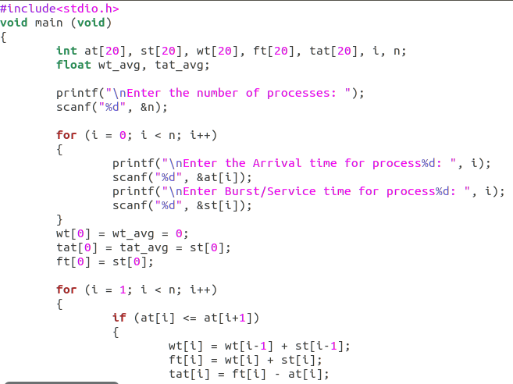

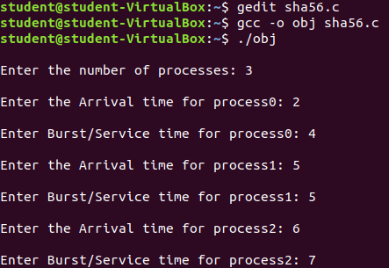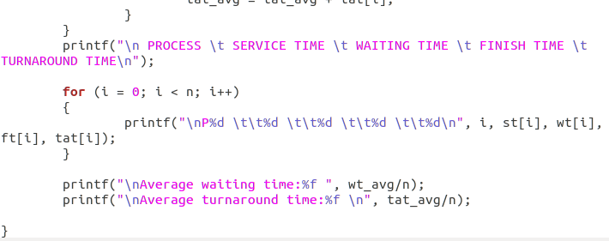

**Output:**

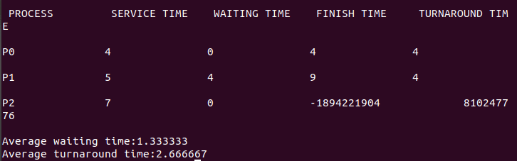

**Task 02:** Modify the FCFS code of example#02 to be able to calculate the mean of Normalized Turnaround Time. Also the modified code should display the Normalized Turnaround Time of each process.

**Solution:**

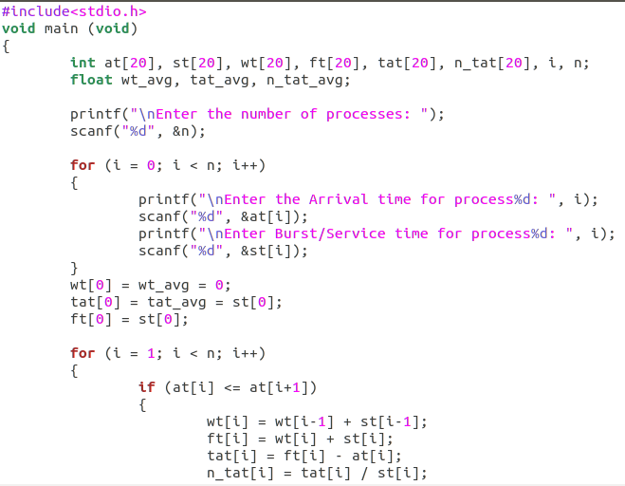

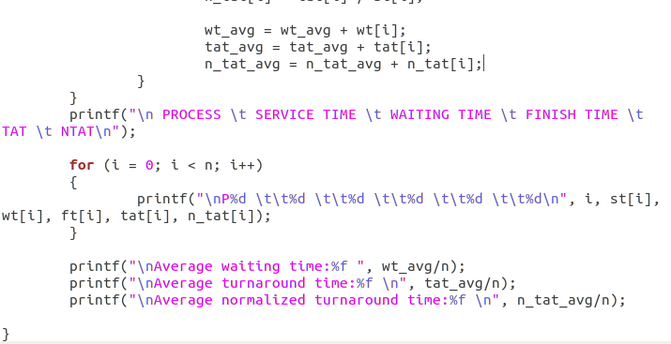

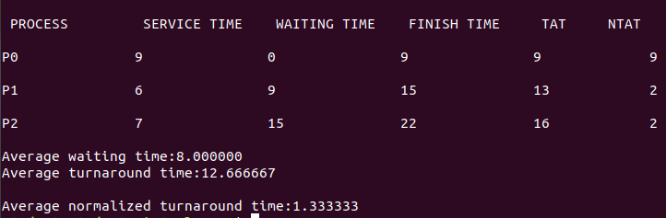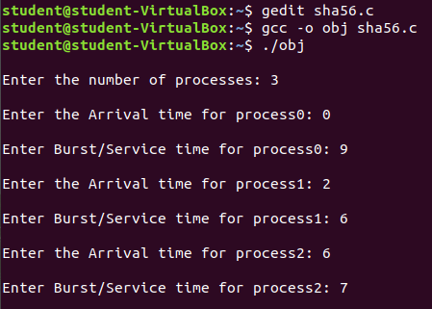**Output:**